**2015 SAMSUNG Global Research Outreach Program Proposal (Manuscript)**

**Theme: Soft Robotics**

Sub-theme: Soft Robotics

**Principal Investigator**

Laboratory for Computational Sensing and Robotics

Department of Mechanical Engineering

Johns Hopkins University

3400 North Charles Street 116 Hackerman, Baltimore, MD, 21218-2682

Office: (410) 516-7127 E-Mail:[gchirik1@jhu.edu](mailto:gchirik1@jhu.edu)

&

Division of Information and Intelligent Systems

National Science Foundation

[gchirikj@nsf.gov](mailto:gchirikj@nsf.gov)

**Co-PI (if applicable)**

**Project Summary**

This project is intended to be a two-year project.

**Abstract**

With the development of robotics technology, robots has been applied to a lot of fields with new applications such as human-robot collaboration in manufacturing environments and robot assisted surgery in clinic. Two problems become critical in such situation: 1) robot hand-eye calibration; 2) adaptive force control. The first problem is ubiquitous in robot application where the calibration of the relative configuration of the end-effector or sensor with respect to the distal end is needed for accurate sensing and task execution. The second problem is useful to both control the robot using force feedback and avoid hurting humans when the robot and human are in contact.

**Goals**

Both new sensor calibration algorithm and force feedback control low will be developed to achieve robust hand-eye calibration and safe human robot collaboration. A specific application in clinic can be catheter tracking inside the patient using ultrasound probe, which has the benefit of low cost and ease of use. Safe control strategy and potential mechanism will be designed to ensure the safety of both the patient and the doctor.

**Keywords: Hand-eye Calibration, Adaptive Force Control**

**Description of Projects**

1. Project Duration

This is planned to be a two year project which starts from Sep. 1st 2015 to Aug. 31st 2017.

1. Research Objectives

An often used formulation of sensor calibration in robotics and computer vision is AX=XB, where A, X, and B are rigid-body motions with A and B given from sensor measurements, and X is the unknown calibration parameter. A probabilistic approach has been developed and will be further improved to solve this problem in a robust and accurate way. Robust and accurate hand-eye sensor calibration which suffers from unsynchronization between the robot and the ultrasound sensor.

Autonomous force based object tracking (catheter tracking)

1. Significance of Research

Calibration side:

Hand-eye calibration is prevalent in robot applications and most of the methods demand exact knowledge of correspondence between sensor readings, and this might not be applicable in certain system setup. A probabilistic approach can solve this problem without synchronizing the system while recover the calibration parameters in an accurate manner.

Force control side:

TO BE ADDED

1. Research Plan and Technical Approach

*Research Plan*

TO BE ADDED.

*Technical Approach*

The probabilistic AX=XB algorithm can be implemented in Matlab, which is a powerful commercial scientific computing software.The core of this part is to employ the property of probabilistic distribution on Lie groups as:



Further mathematical modeling will be developed based on this or similar concept. Several related publications have been available such as …

The LCSR laboratory in Johns Hopkins University is equipped with several UR5 robot bought from the Universal Robot company. This is a light weight industrial robot arm which is collaborative and safe due to the built in force sensors. However, the safety feature is for industrial environment instead of clinical application.

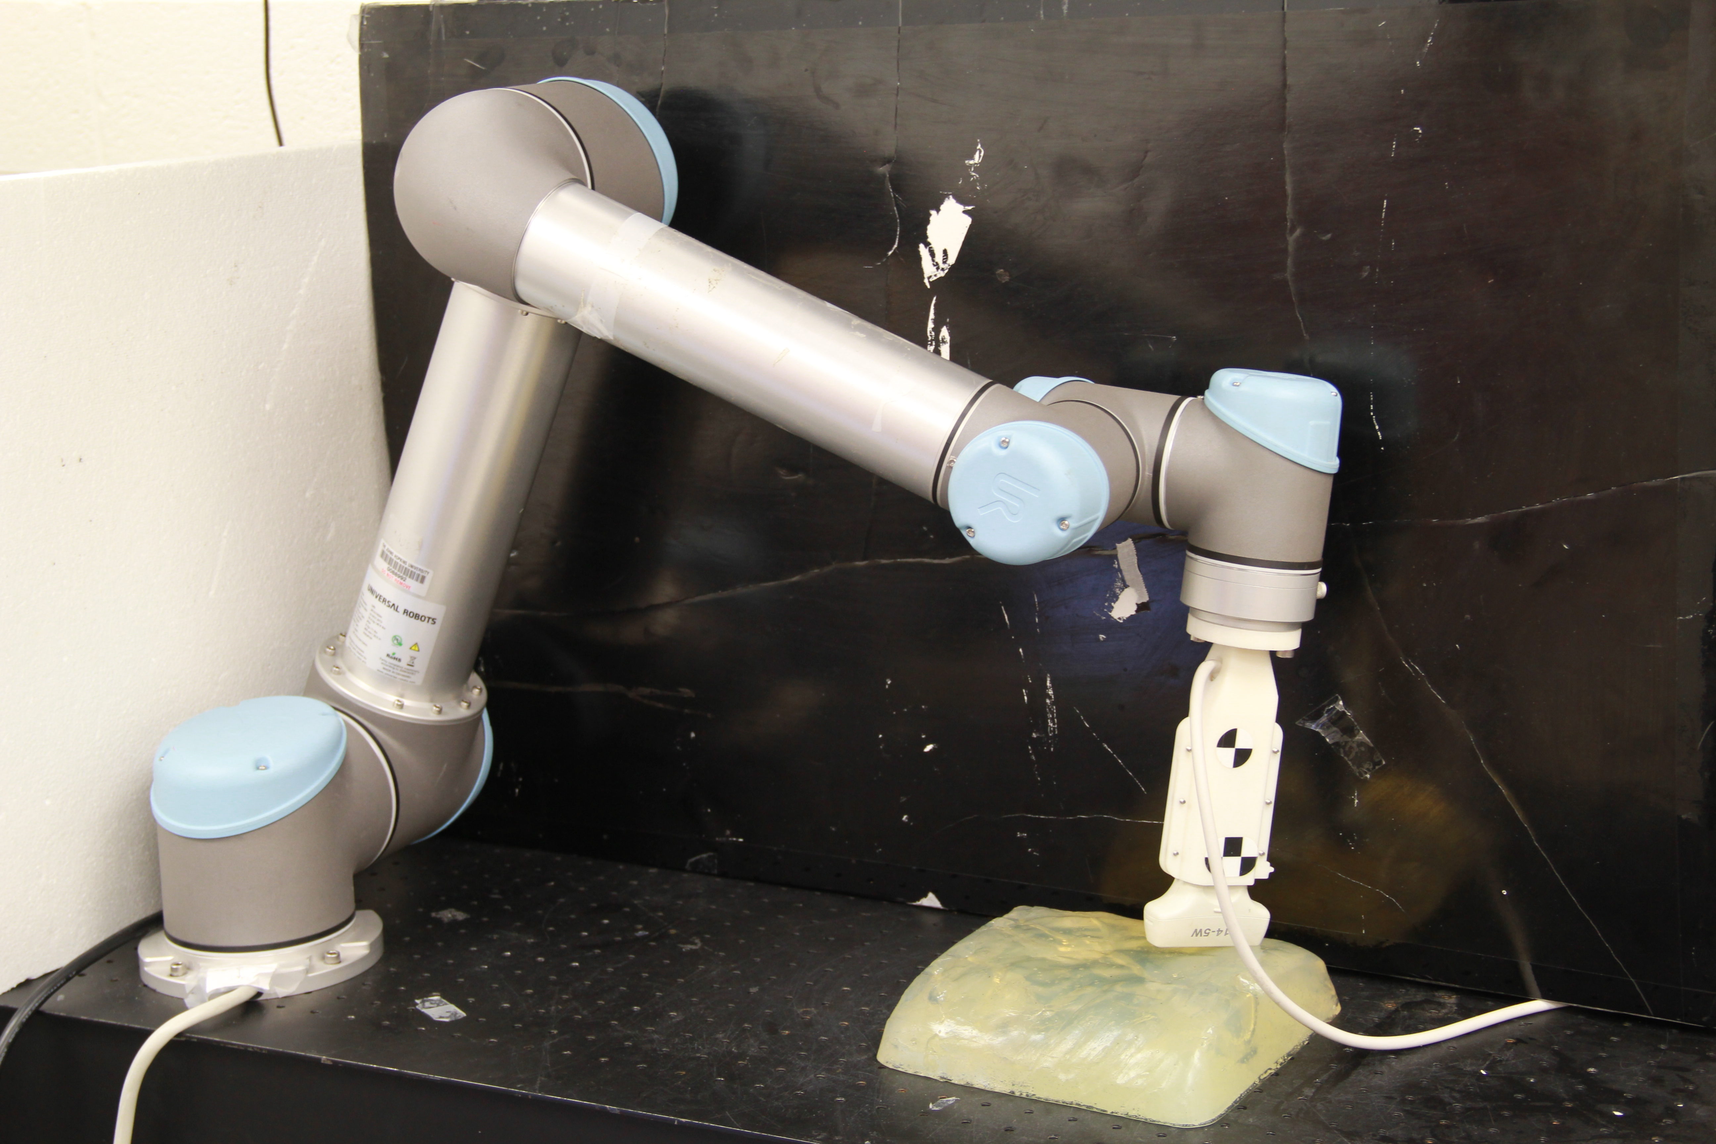

Figure 1. UR5 Light-weight Robot Arm with Ultrasound Probe Attached at the Distal End

ROS ( Robot Operating System ) is an open source platform that is powerful in but not limited to robot algorithms development. It provides many libraries for robot control and visualization and supports many different types of robots. ROS Industrial is an open source platform designed specifically for industrial robots and the support for UR5 is under development which can be used to facilitate the control strategy development.

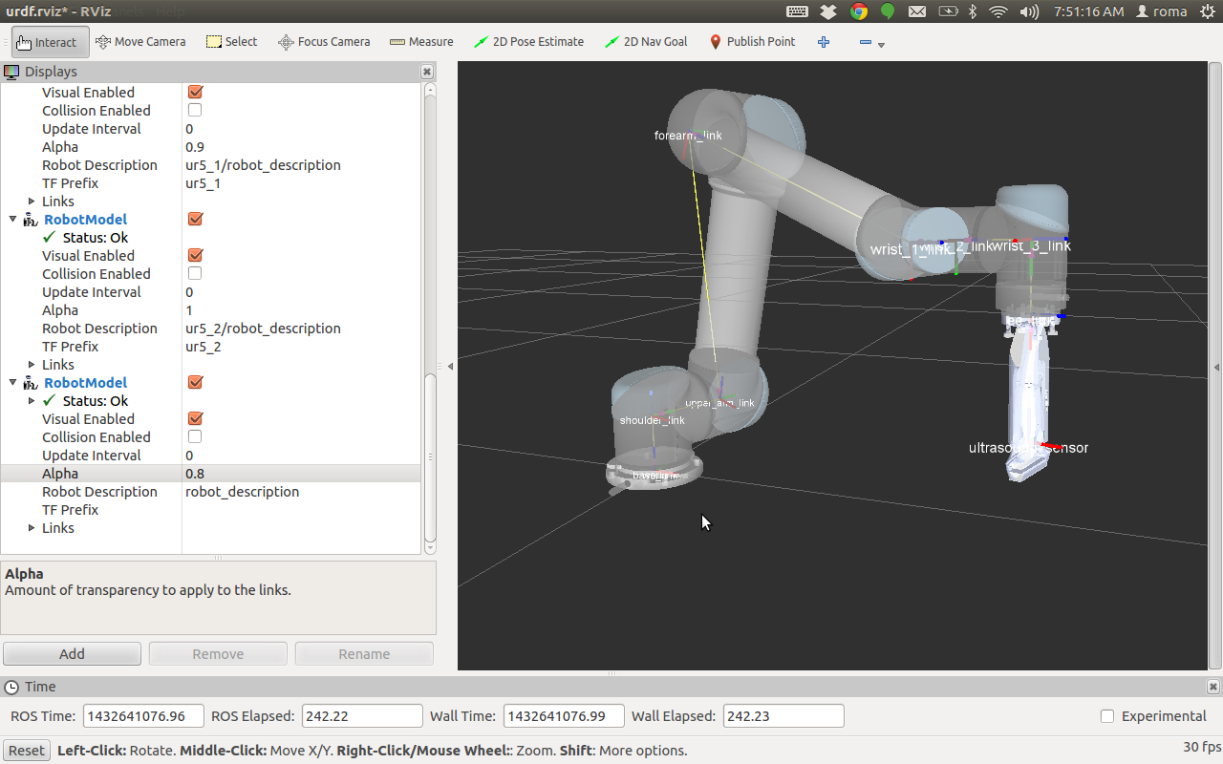

Figure 2. Simulation of UR5 Robot and Ultrasound Probe in ROS Environment

DESCRIPTION OF TRACKING AND CONTROL STRATEGY TO BE ADDED.

1. Milestones (Only include one year even for a two year project)

Month 1: Literature review of existing AX=XB algorithms and basic system setup

Month 2: Mathematical formulation of the new probabilistic version of AX=XB problem

Month 3: Numerical test of the probabilistic AX=XB algorithm

Month 4: System setup and experiment test of the probabilistic AX=XB algorithm

Month 5: Algorithm analysis and comparison with other methods

Month 6: Literature review of ultrasound feedback servoing and basic system setup

Month 7: Implement the communication system among the ultrasound machine, UR5 robot arm and ROS operating system

Month 8: Catheter tracking strategy design (without force feedback)

Month 9: Adaptive force feedback control design

Month 10: Implementation and Experiment

Month 11: Implementation and Experiment

Month 12: Improvement of core functionalities and report write up

1. Expected Outcomes and Results (describe tangible outcomes and intangible outcomes separately)

Tangible outcomes:

* Roboust and accurate sensor calibration through probabilistic approach.
* Safe phantom contour following based on force feedback control.
* Autonomous catheter tracking using ultrasound

Intangible outcomes:

Gesture enabled fast reaction control for safety.

**Budget**

(Describe direct expenses and indirect costs up to $100,000 overall)

Direct Costs:

Student Salary ( one student ): 2 years * $28,000 /per year= $56,000

Equipments:

Workstation with Multiple Monitors: $1,300 - $2,000

Force Sensor: from few hundreds to $4,000

Other Electronics: hundreds of dollars

Others:

Indirect Costs:

Mechanism Design (e.g. 3D printing) : $500

**Appendix**

1. CVs of PI, Co-PI(s), and the proposed graduate students
2. Equipment or Facilities
   1. UR5 Light-weight Robot Arm
   2. Workstation with Multiple Monitors
   3. Ultrasound Machine
   4. Force Sensor
   5. (Gesture Control Armband)
3. Others
4. External Funding (if applicable)